**Advanced Data Analysis Report**

**1. Data Overview**

* The key variables analyzed include **Sales, Promotions, Discounts, Season, Year, and Month**.

**2. Time Series Analysis**

**2.1 Sales Trend Over Time**

* A time series plot of daily sales showed significant fluctuations over time.
* There is an overall upward trend in sales, indicating business growth.

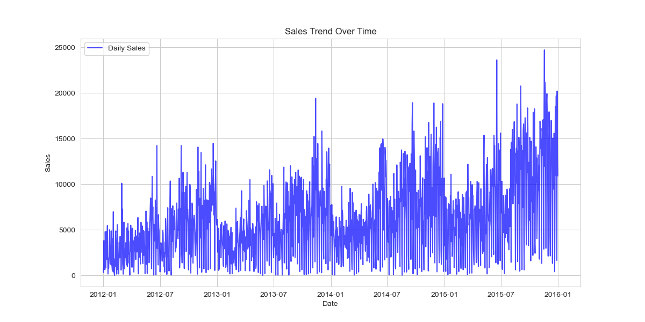

**2.2 Seasonal Decomposition**

* The **trend component** showed a steady increase in sales over time.
* The **seasonal component** revealed repeating sales patterns, likely linked to holidays and promotional events.
* The **residual component** contained noise, representing random fluctuations.

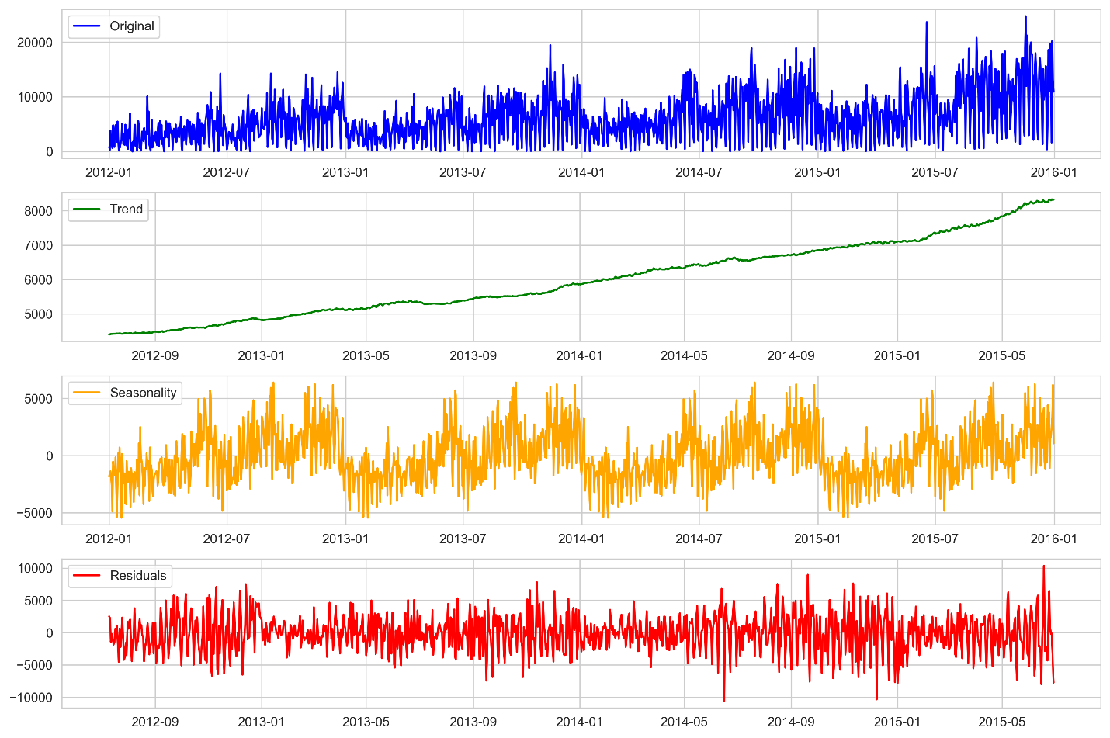

**2.3 Stationarity Check (ADF Test)**

* **ADF Statistic:** -2.923
* **p-value:** 0.043
* Since the p-value is **less than 0.05**, we **reject the null hypothesis**, indicating that the sales data is **weakly stationary**.
* Further differencing may be needed for improved forecasting.

**3. Correlation Analysis**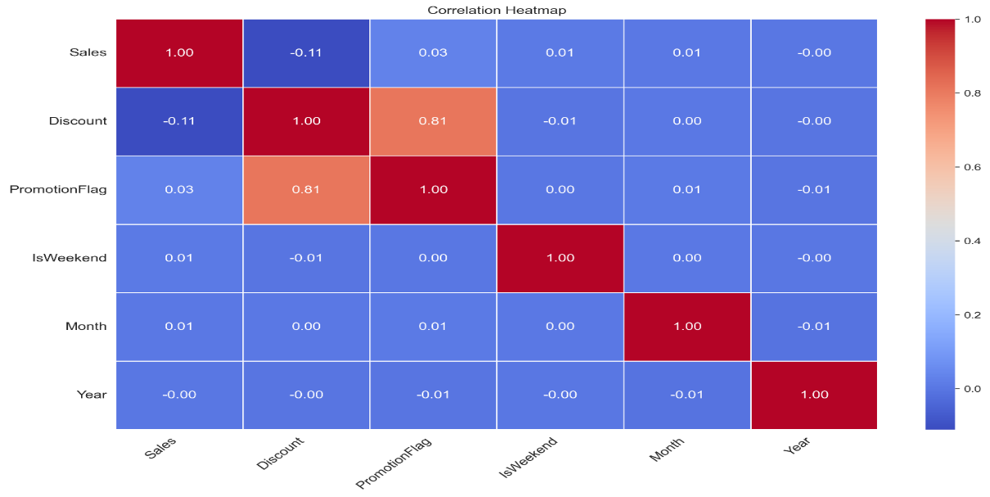

**3.1 Key Findings**

* **Sales & Promotion Flag (0.029 correlation):** Promotions have a minimal impact on increasing sales.
* **Sales & Discounts (-0.11 correlation):** Discounts have a weak negative correlation with sales.
* **Sales & Weekends (0.008 correlation):** Almost no correlation between weekends and sales.

**4. Conclusions & Recommendations**

* The time series analysis confirms an **upward sales trend** with **seasonal patterns**.
* Promotions and discounts **have minimal impact on sales**, suggesting other factors drive revenue.
* The sales data is **weakly stationary**, meaning it might need further differencing before modeling.
* Future work can involve **forecasting models** such as ARIMA or machine learning techniques to predict future sales patterns.

*End of Report*